**Rotational Cordic**

Rotaional cordic is a sub-module to rotate a certain point with certain angle or to calculate the cos and sin of a certain angle by starting with a point on x axis with magnitude equal to 1.

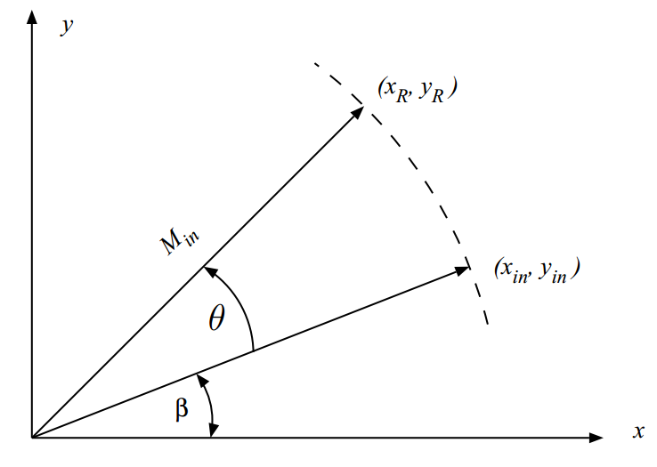

Algorithm:

The cordic algorithm is an iterative algorithm that use the sign of a variable to decide the next operation.

In our case rotational cordic we use the sign of angle theta to decide to add or to sub.

In first iteration we load the internal registers with the input x , y and angle , then we start the 12 iterations using pip-line architecture to cut-out critical path into number of paths put with larger latency.

Equations:

Each iteration the angle is changing to reach zero after large number of iterations.

* We used rotational cordic in our design to rotate matrix elements by a certain angle that output from vector cordic (appling Given’s rotation method).
* Rotational cordic used also to calculate sin and cosine of theta angle to calculate the Q matrix in QR decomposition.